

**Comprehensive Report on an AI-Powered SWOT Analysis WebApp**

**Executive Summary**

TransGlobal Industries and other forward-thinking organizations require actionable insights to stay competitive in a dynamic marketplace. Our AI-powered SWOT Analysis WebApp delivers these insights by automating the process of analyzing an organization’s strengths, weaknesses, opportunities, and threats. Built on advanced technologies including **Streamlit**, **LangChain**, **FAISS**, **Google Generative AI**, and **Plotly**, this solution converts detailed organizational information into a comprehensive SWOT analysis, complete with interactive visualizations.

**Primary Delivery – Proof-of-Concept (POC):**  
The Proof-of-Concept (POC) demonstrates the end-to-end capabilities of the WebApp from input processing through automated analysis and visualization showcasing how the system provides strategic, data-driven insights that significantly enhance decision-making efficiency in the workplace.

**1. Introduction**

In an era where rapid strategic decision-making is essential, understanding the internal and external factors affecting an organization is critical. Traditional SWOT analyses often suffer from subjectivity and delays due to manual processing. Our AI-powered WebApp addresses these challenges by automating the entire SWOT analysis process. This report, prepared from a client perspective, details the technology, workflow, and benefits of the solution while emphasizing the POC as our primary delivery.

**Key Points:**

* **Purpose:** To accept organizational details as input and generate an insightful, actionable SWOT analysis.
* **Relevance:** With businesses increasingly relying on data-driven strategies, this WebApp demonstrates how AI can be leveraged to provide nuanced business insights.

**2. Technology Stack**

The solution utilizes a modern technology stack designed for both robust performance and ease of use:

* **Streamlit:**
  + Provides a user-friendly interface with modern design elements such as glassmorphism, smooth animations, and responsive layouts.
  + Supports rapid development of interactive dashboards and data visualizations.
* **LangChain:**
  + Enables chaining of language model operations and integrates with retrieval systems.
  + Utilized to create a custom prompt template that guides the generation of a detailed SWOT analysis.
* **FAISS (Facebook AI Similarity Search):**
  + Powers vector-based retrieval by indexing key SWOT concepts.
  + Enhances the relevance of the retrieved context for generating tailored SWOT insights.
* **Google Generative AI:**
  + Drives the natural language processing capabilities.
  + Works in tandem with LangChain to produce rich, context-aware analysis using Retrieval-Augmented Generation (RAG).

**3. Proof-of-Concept (POC) Overview**

**3.1 POC Objectives and Scope**

The POC is our primary delivery and demonstrates the core functionalities of the SWOT Analysis WebApp. It is designed to:

* Validate end-to-end automation—from data input to interactive visual output.
* Showcase the accurate conversion of organizational details into actionable SWOT insights.
* Highlight the integration of advanced AI techniques with user-friendly design.
* Demonstrate tangible benefits such as increased efficiency, objective analysis, and enhanced decision-making.

**3.2 User Input Processing**

* **Input Methods:**
  + Users can either manually enter organization details or upload documents (TXT, PDF, DOCX).

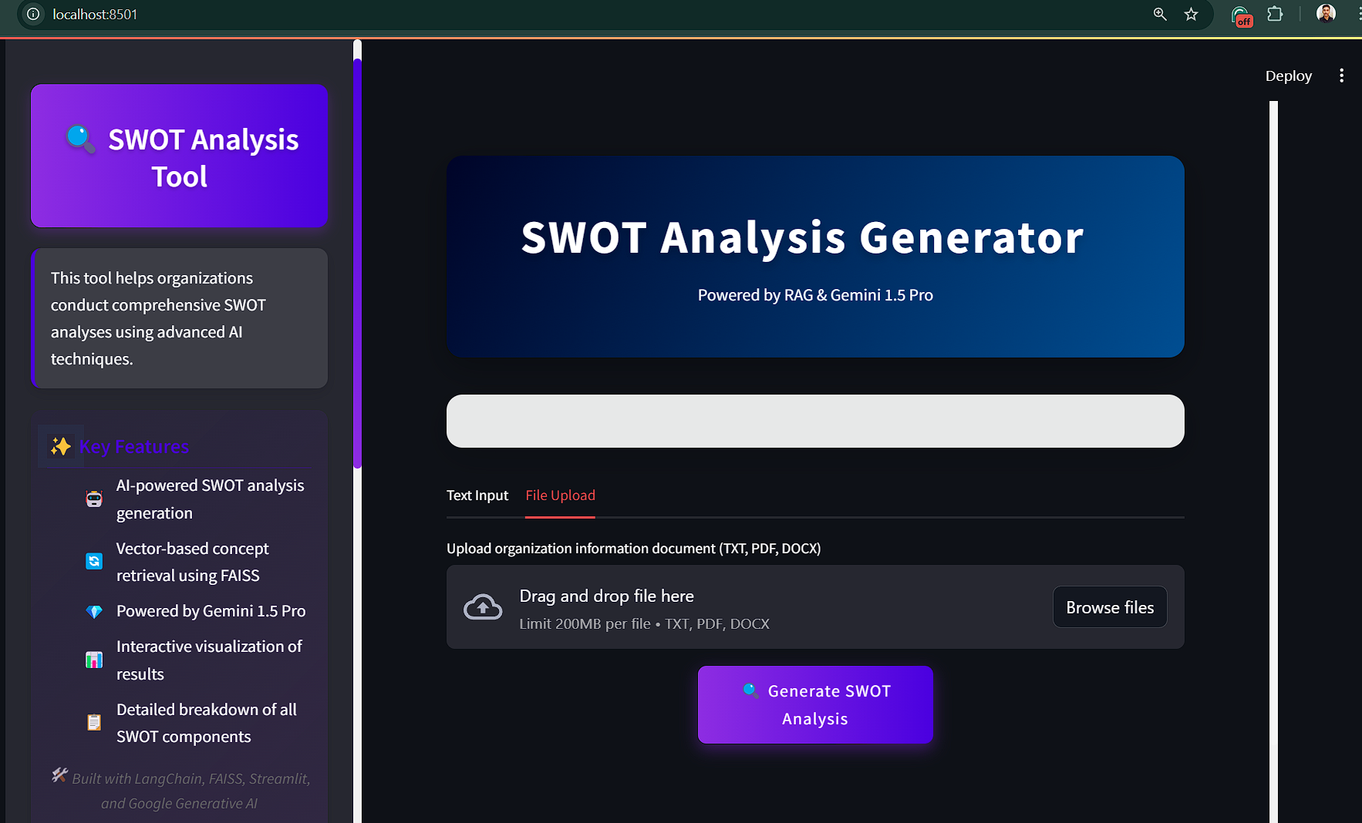

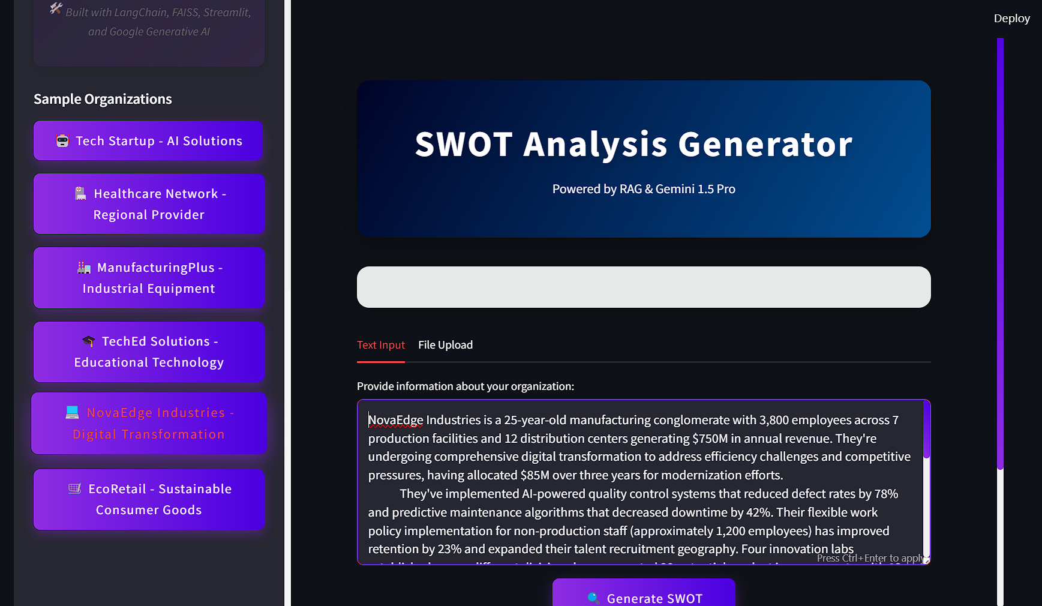

Upon clicking any of the Sample Organizations, that **industry Specific** Company Information will be populated in the text input section.

* **Data Handling:**
  + The app stores the input text and processes it through an AI-driven pipeline.

**3.3 Prompt Template & AI Analysis**

* **Custom Prompt Template:**
  + A detailed template instructs the AI on how to structure the SWOT analysis.
  + The template divides the analysis into four sections (Strengths, Weaknesses, Opportunities, Threats) and requires actionable insights with specific examples.

For FAISS vector store , documents has been created for each SWOT components

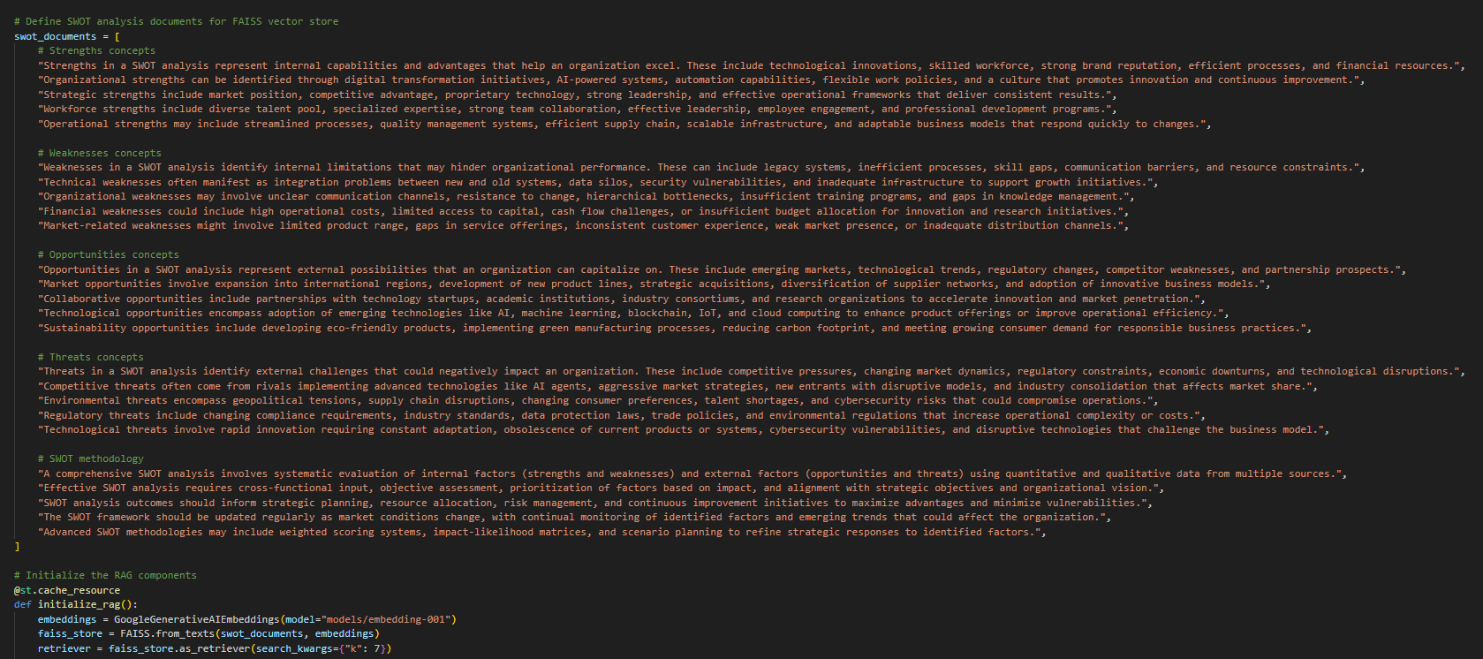

* **Enhances retrieval efficiency** by leveraging FAISS for fast vector-based search.
* **Ensures structured SWOT insights** for better strategic decision-making.

*Custom Prompt template with clear context, task and assigning a persona*

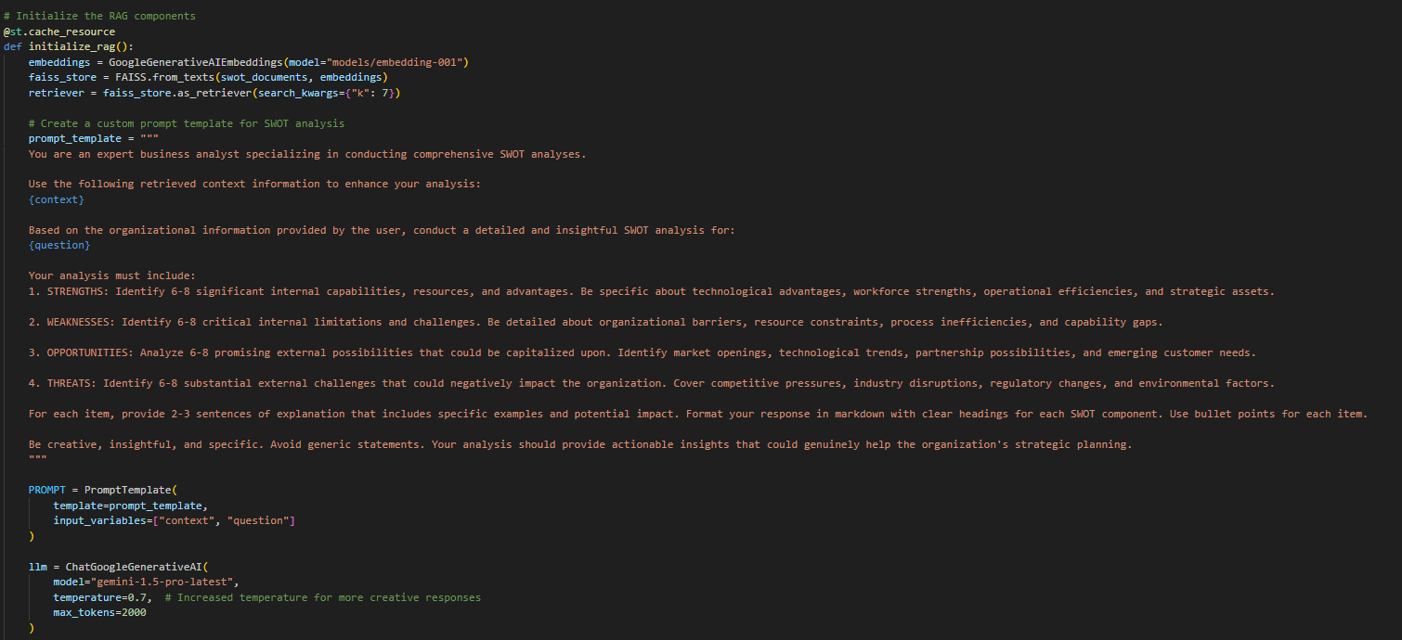**Retrieval-Augmented Generation (RAG):**

* + FAISS retrieves relevant contextual information, enhancing the AI’s analysis accuracy.

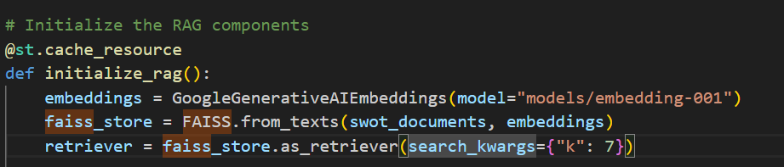

* + The system dynamically integrates retrieved data with user input to generate a complete SWOT report.

**4. Implementation Details**

**4.1 FAISS-Based Retrieval**

* **Contextual Indexing:**
  + Key concepts related to SWOT (e.g., digital transformation, legacy system challenges, market dynamics) are pre-indexed.

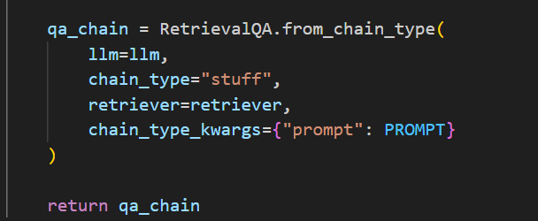

* **Enhanced Relevance:**
  + When user input is provided, FAISS quickly retrieves relevant concepts, which are then incorporated into the custom prompt to guide the analysis.

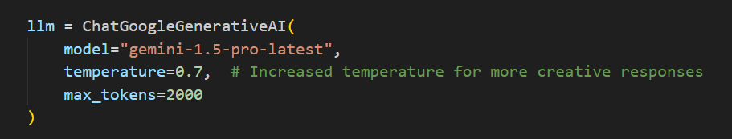

*This setup balances creativity and response length for optimal generative output*

**4.2 User Interface Components**

* **Streamlit Layout:**
  + The UI is divided into tabs for text input and file upload, ensuring flexibility in how data is provided.
  + A futuristic design with animated elements and glassmorphism styling enhances user engagement.
* **Interactive Elements:**
  + Buttons and progress indicators provide real-time feedback during the SWOT analysis generation process.

**4.3 Dynamic AI-Driven Insights**

* **Customized Analysis:**
  + The AI uses the custom prompt to generate detailed insights for each SWOT component.
* **Output Structure:**
  + The final report is structured with clear headings, bullet points, and concise explanations (2–3 sentences per item) to facilitate quick comprehension and actionable recommendations.

**5. POC Demonstration Flow**

**5.1 Conversion of Organizational Data**

* **Mechanism:**
  + The AI agent employs custom prompt templates to transform organizational information into structured SWOT components.
* **Output:**
  + Detailed descriptions for each SWOT category, enabling actionable insights and strategic planning.

**Section 1: SWOT Overview**

*General Overview of the SWOT Components*

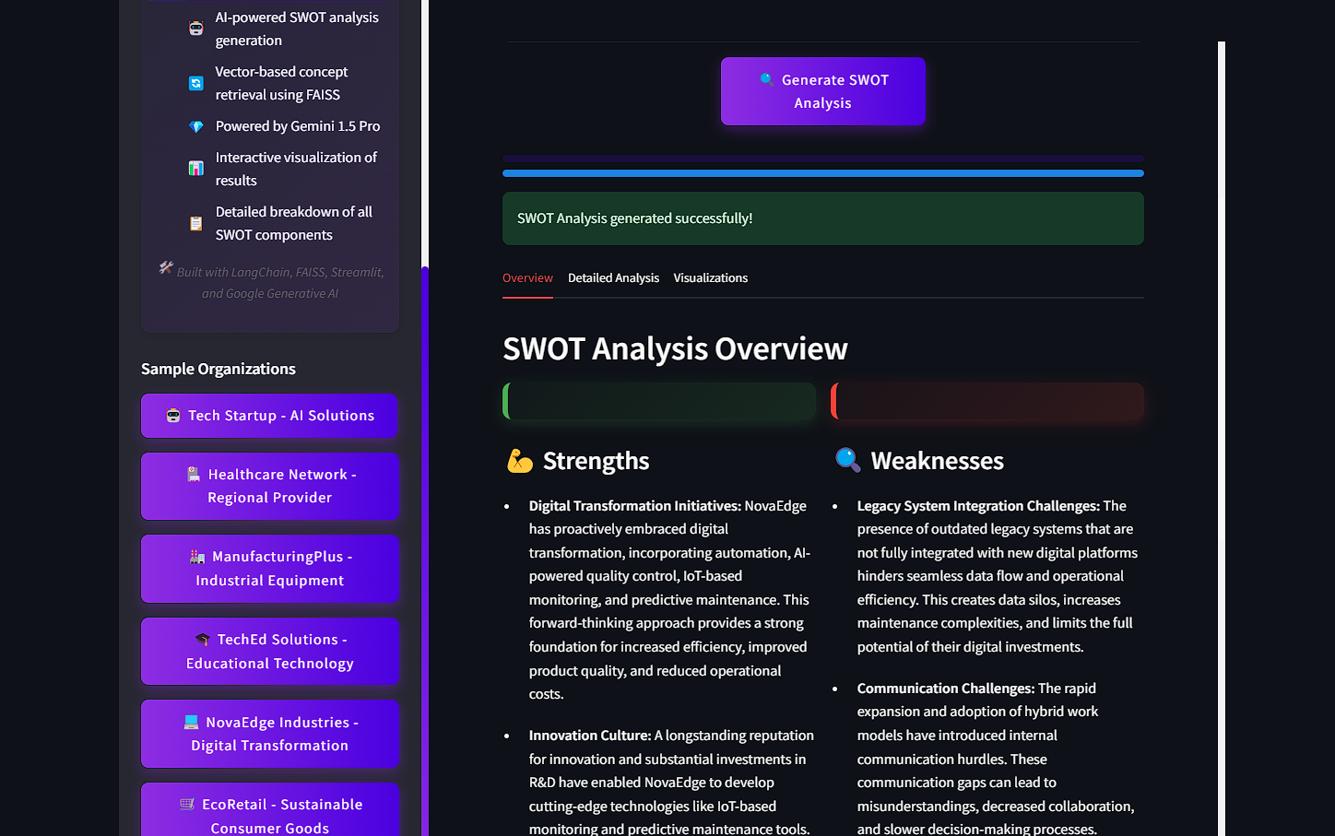

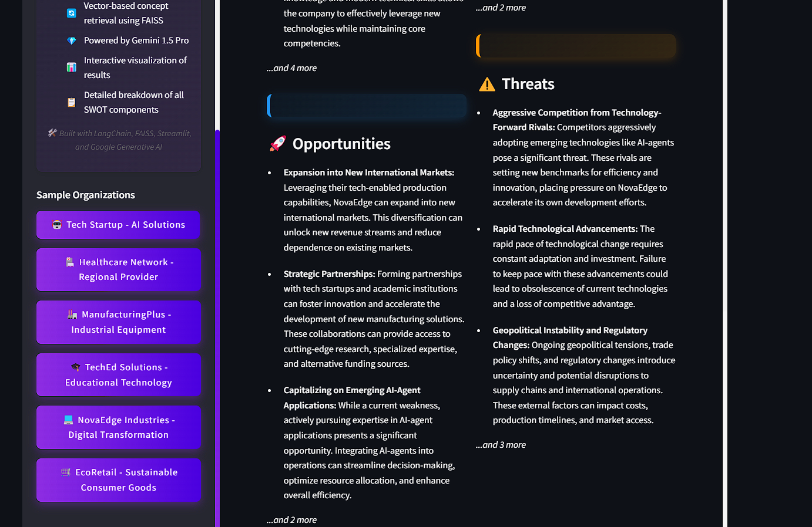

**Section 2: Detailed Analysis**

**5.2 Generation of SWOT Analysis Report**

* **Methodology:**
  + The system generates a comprehensive report that includes clear sections for Strengths, Weaknesses, Opportunities, and Threats.
* **Advantage:**
  + Ensures consistency and clarity, reducing ambiguity and supporting objective analysis.

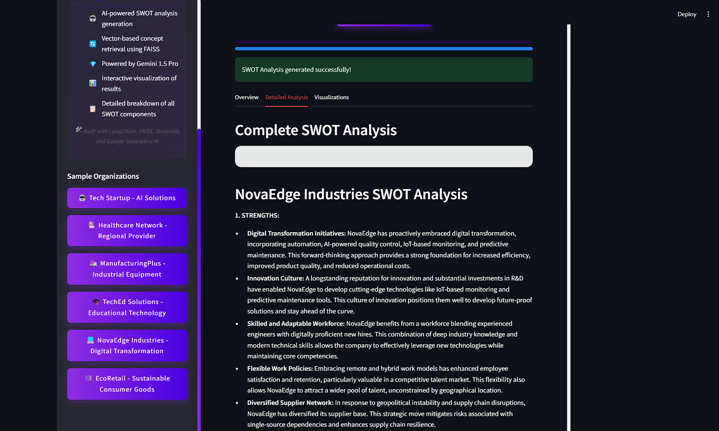*Comprehensive and Detailed Analysis of each SWOT components*

**5.3 Interactive Visualization & Analysis**

* **Visualization:**
  + Plotly charts provide dynamic, interactive displays of the SWOT components.
* **Analysis:**
  + Visual insights facilitate quick comparison and in-depth understanding of the organizational landscape.

**Section 3:** **Visualization**

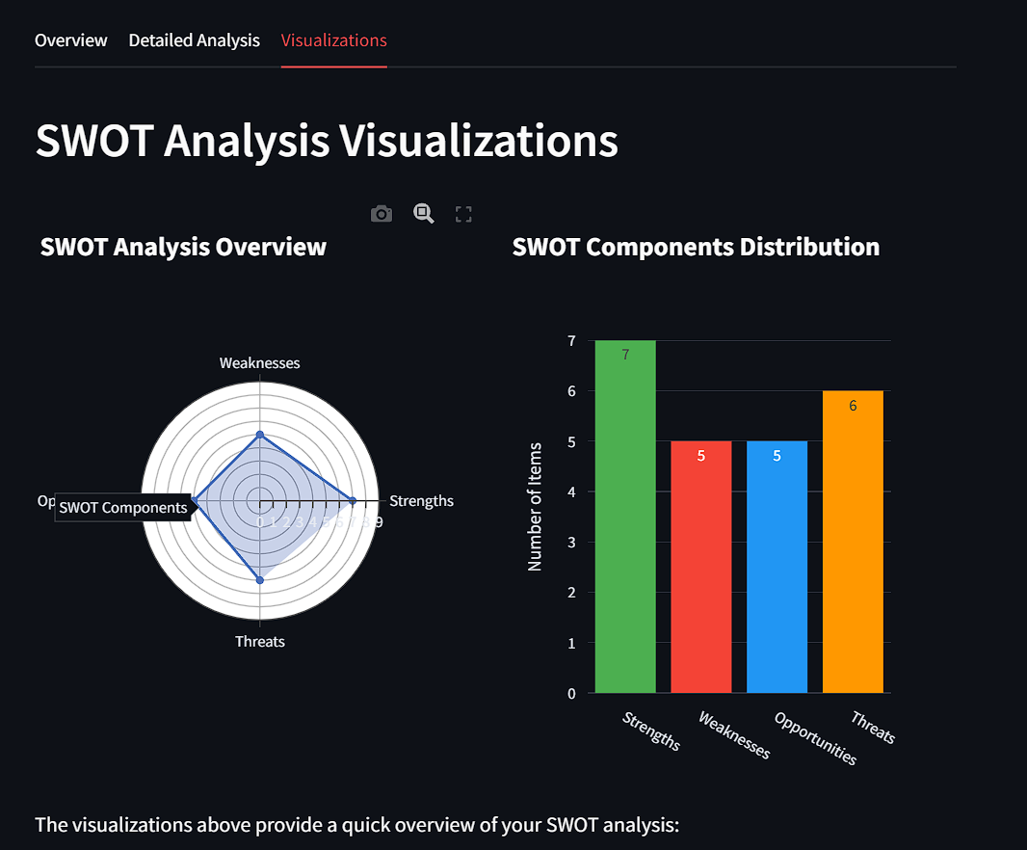

*This distribution highlights the key components of the SWOT analysis, showcasing the balance between strengths, weaknesses, opportunities, and threats.*

* + 1. **POC Deliverables**

| **Deliverable** | **Description** |
| --- | --- |
| **Interactive Dashboard** | A user-friendly interface for inputting data and tracking the analysis process in real time. |
| **SWOT Analysis Report** | A detailed document outlining the generated Strengths, Weaknesses, Opportunities, and Threats. |
| **Dynamic Visualizations** | Plotly-powered charts that provide a visual summary of the SWOT components. |
| **Executive Summary** | A concise overview highlighting the key insights and strategic recommendations derived from the SWOT analysis. |

**7. Client Benefits from the POC**

* **Operational Efficiency:**
  + Demonstrates significant reductions in manual analysis time and error rates.
* **Enhanced Strategic Insight:**
  + Provides objective, data-driven insights that support informed decision-making.
* **User-Centric Design:**
  + The interactive dashboard and visualizations offer an engaging and intuitive user experience.
* **Scalability and Adaptability:**

The POC highlights a scalable solution that can be tailored to various industries and organizational needs.

**8. Conclusion & Strategic Implications**

The development of this AI-powered SWOT analysis WebApp underscores the transformative potential of integrating AI into strategic business planning. By leveraging Streamlit, LangChain, FAISS, and Google Generative AI, the tool provides:

* **Actionable Insights:** Detailed, context-aware analyses that guide strategic decision-making.
* **Enhanced Efficiency:** Automation of complex analysis tasks, allowing businesses to quickly adapt to market changes.
* **Scalable Solutions:** A robust framework that can evolve to include advanced NLP techniques and broader benchmarking capabilities.

**Final Thoughts:**  
AI is revolutionizing the way organizations approach strategic planning. By providing detailed, data-driven SWOT analyses, this WebApp not only streamlines the analytical process but also empowers decision-makers to tackle challenges proactively and seize emerging opportunities.